A broken system

Smoke released by cooking in non-ventilated places is one of the world’s leading cause of illness and death.

According to the <a href=http://www.who.int/mediacentre/factsheets/fs292/en/>World Health Organization</a>, it can cause respiratory infections, lung cancer, heart disease and blindness, as well as short term suffering such as coughing, burning eyes, chest pain and headaches.

The prey of the silent killer in the kitchen? The people who spend the most time indoors: in the developing world, mainly women and children.

More than half of premature deaths among children under the age of five are due to pneumonia caused by breathing this smoke, and there is evidence of a link between indoor air pollution and <a href=http://cleancookstoves.org/binary-data/RESOURCE/file/000/000/471-1.PDF>low birth weight</a>.

Dr Wezzie Mumba, Senior Medical Officer at the Bwaila Hospital, Lilongwe – Malawi’s capital city – sees how critical the situation is. ‘The women who do come to the clinics have severe lung problems,’ he says. ‘Problems that usually only chainsmokers have.’

Only 0.4 per cent of the women in Malawi are smokers – but experts have likened just one hour of cook smoke to <a href=http://www.who.int/features/2014/clean-household-energy/en/>burning 400 cigarettes</a>.

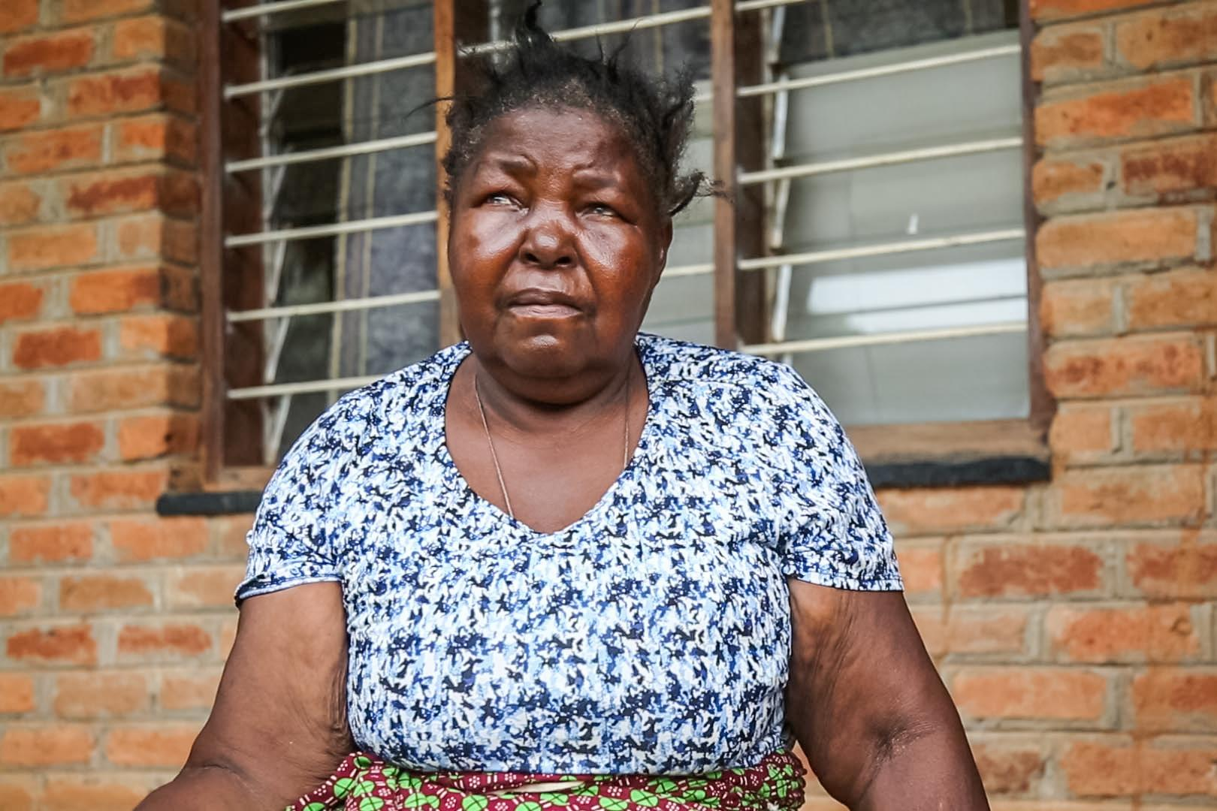
Ms. Phirie suffers from lung problems - she coughs, is dizzy and has trouble walking. She comes in an out of hospital frequently as the doctors can't seem to identify the cause of her illness. Ms. Phirie has lung problems - yet she never smoked.

How does Dr Mumba recognize the cause might be unclean cooking? ‘The hairs on their arms are all gone because of the open fire,’ he says.
Basic health-care is free of charge in Malawi but clinics are understaffed and underfunded: there are only a whopping two doctors available per 100,000 patients. Medication is also scarce.
Matron Phirie of Chintheche Rural Hospital in Nkhata Bay district in the north of the country says that, therefore, it is difficult to treat smoke related diseases. ‘We are unable to find out the causes – there is not even an x-ray machine in the clinic,’ she says, adding that health practitioners ‘just prescribe antibiotics – that is all we have,’ without really knowing what the (cause of the) illness is.
‘We can only treat presumably for chest infections and pneumonia. But so many come back and back.’
Not only do doctors need to know what caused a disease to treat it well, they also need data to measure the scale of the crisis – data that currently does not exist. And not having this data on hospital or national level is crippling Malawi’s response: where there is no data, there is no information and often – no donor funding.
Dr Mumba believes that most funding is earmarked for the prevention and treatment of HIV/AIDS, malaria and tuberculosis. ‘That is where the donors give money for.’
Even with around 13,000 deaths per year <a href=http://www.who.int/quantifying_ehimpacts/national/countryprofile/malawi.pdf>attributed</a> to indoor air pollution – a total of 8.6 per cent of deaths in the country – it seems difficult for the ‘killer in the kitchen’ to make it on the country’s (public) health agenda.

